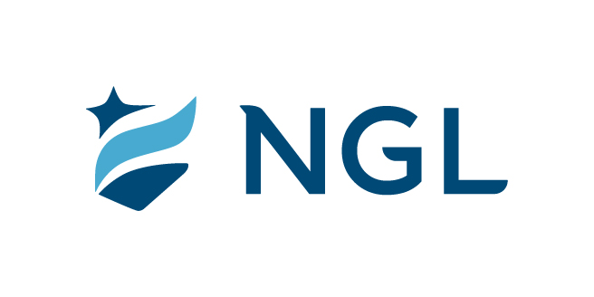
March 25, 2021
For immediate release

Contact: Maria Lubick
mdlubick@nglic.com

Online newsroom: nglic.com/newsroom

AM Best Upgrades National Guardian Life Insurance Company
Credit Ratings to A (Excellent)

Madison, Wis. (March 25, 2021) – National Guardian Life Insurance Company (NGL) is pleased to announce AM Best has upgraded its Financial Strength Rating to A (Excellent) from A- (Excellent) rating effective March 24, 2021. The outlook of these ratings has been revised to stable from positive. This rating reflects the excellent ability of NGL to meet its ongoing insurance policy and contract obligations and further attests to its financial strength.

“Last year NGL finished with capital and surplus reaching historic records. Our strong financial position is the result of generations of employees consistently doing what is right and always putting our policyholders first. This rating both confirms our strength and stability, and gives us confidence to enter new markets so that we can expand our societal impact,” said Knut Olson, NGL President & CEO.

AM Best has also upgraded NGL subsidiary, Commercial Travelers Life Insurance Company, to A (Excellent) rating with stable outlook.

“Despite the challenges NGL faced in 2020 with the pandemic’s impact on sales and claim levels combined with the low interest rate environment, NGL had a solid year from an income perspective. We strengthened our balance sheet by selling blocks of business, updating our investment strategy and managing risk. Through these actions, total adjusted capital has reached $451.8 million with an RBC ratio of 556 percent, the highest level in NGL’s history,” said Nancy Stoddard, NGL Senior Vice President, Chief Financial Officer and Chief Actuary.

According to a news release from AM Best, the rating upgrades are driven by continuing improvements in NGL’s balance sheet, including a decline in financial leverage from the pay-down of surplus notes, favorable capital and surplus growth on an absolute and risk-adjusted basis, and a conservative investment portfolio. AM Best also noted that operating earnings remained consistent in 2020 despite the challenges of operating in a pandemic environment.

AM Best is the world’s oldest and most authoritative insurance rating information source. The financial strength rating is based on a comprehensive quantitative and qualitative evaluation of a company’s balance sheet strength, operating performance and business profile.

As a longtime leader in the insurance industry, NGL is dedicated to serving policyholders and partners by offering high-quality products that are among the safest and most stable in the industry.

To learn more about NGL’s financial strength and stability visit our website, www.nglic.com. For the latest rating, access www.ambest.com.

About NGL
Established in 1909 National Guardian Life Insurance Company (NGL) is an insurance company headquartered in Madison, Wis. Licensed to do business in 49 states and the District of Columbia, NGL markets preneed and individual life and annuities, as well as group markets products. Information about NGL can be found at www.nglic.com; Facebook: Facebook.com/NGLIC and LinkedIn: https://www.linkedin.com/company/national-guardian-life-insurance-company.

About Commercial Travelers Life Insurance Company
Commercial Travelers Life Insurance Company became a wholly owned, stock subsidiary of National Guardian Life Insurance Company in 2017.

Ratings current as of 03/24/21. National Guardian Life Insurance Company is not affiliated with The Guardian Life Insurance Company of America a/k/a The Guardian or Guardian Life.

###
PRAM32021

