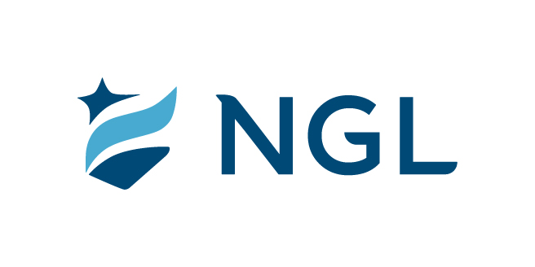
April 2, 2024
For immediate release

Contact: Maria Lubick
mdlubick@nglic.com

Online newsroom: nglic.com/newsroom

NATIONAL GUARDIAN LIFE INSURANCE COMPANY NAMES JOSEPH CELENTANO AS NEW CEO

MADISON, WI (April 2, 2024) -- National Guardian Life Insurance Company (NGL) Board of Directors announced today that Joseph (Joe) Celentano will join the Madison Wisconsin-based mutual life insurance company as President & CEO effective May 6. Celentano will also serve on the NGL Board of Directors.

Celentano is an experienced life insurance industry professional with more than 30 years in leadership positions at Pacific Life, a mutual based insurer. He most recently served as Executive Vice President of Pacific Life’s Retirement Solutions Division during which he managed the impacts of the Covid pandemic while increasing profitable annuity sales through the launch of new and innovative annuity products.

“Joe’s extensive mutual life experience and risk management expertise combined with his leadership skills will serve us well as he leads NGL’s next phase of growth,” said Gary Wolter, chair of NGL’s Board of Directors. “He knows the mutual insurance culture, understands the important role our preneed products have in helping families, and values building partnerships.”

While at Pacific Life, Celentano held a variety of positions ranging from product development officer to divisional CFO, to enterprise-wide Chief Risk Officer. His most recent position was Executive Vice President with overall responsibility for the Retirement Solutions Division. Joe’s experience includes co-chairing the company’s Diversity, Equity and Inclusion initiatives, leading digital transformation efforts and participating in setting overall company strategy.

“I am honored to lead NGL and become part of the team,” said Celentano. “NGL’s strong financials, leading position in the preneed market and mutual company culture make NGL poised for future success. My wife Kathy and I look forward to moving and settling in Madison.”

Kim Shaul, who served as interim CEO, will return to her position as Executive Vice President and Chief Legal Officer, working with Celentano for a seamless leadership transition. “On behalf of the NGL Board of Directors I would like to thank Kim for her leadership in keeping the company focused and profitable during the time of the search,” said Wolter.

About NGL

Established in 1909 National Guardian Life Insurance Company (NGL) is an insurance company headquartered in Madison, Wis. Licensed to do business in 49 states and the District of Columbia, NGL markets preneed and individual life and annuities, as well as group markets products. Information about NGL can be found at http://www.nglic.com; Facebook: Facebook.com/NGLIC and LinkedIn: https://www.linkedin.com/company/national-guardian-life-insurance-company.

National Guardian Life Insurance Company is not affiliated with The Guardian Life Insurance Company of America a/k/a The Guardian or Guardian Life.

###

PRCEOANN 0324

