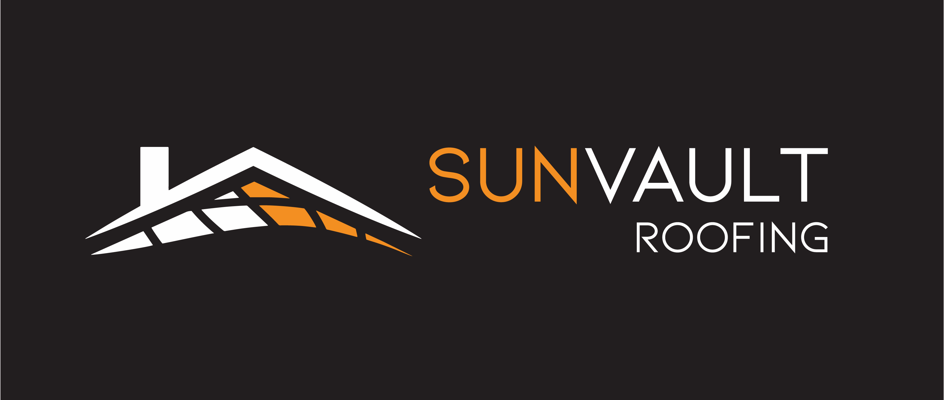

### **Sun Vault Roofing Introduces Innovative Solar Shingles to Madison Homes and Businesses**

**Madison, WI –** Sun Vault Roofing is excited to announce the availability of our cutting-edge solar shingles, offering Madison residents and businesses a seamless integration of renewable energy into their properties.

**Key Features:**

* Integrated Design: Our solar shingles combine the durability of traditional roofing materials with efficient solar technology, eliminating the need for separate solar panel installations that can compromise roof integrity.
* Aesthetic Appeal: Designed to blend seamlessly with various architectural styles, our solar shingles maintain the visual appeal of your property while harnessing clean energy.
* Durability: Built to withstand Madison’s diverse weather conditions, our shingles offer robust protection against snow loads, heavy rains, and high winds.
* Cost Efficiency: By generating electricity directly from your roof, our solar shingles can significantly reduce energy bills, offering a return on investment over time.
* Environmental Impact: Embracing solar technology reduces reliance on fossil fuels, contributing to a cleaner, more sustainable environment.
* Trusted Manufacturer: Our solar shingles are manufactured by CertainTeed, a leader in high-performance roofing materials with over 100 years of industry expertise. They come with a 30-year warranty on roof integrity and a 25-year warranty guaranteeing 80% solar production.

**About Sun Vault Roofing:**

With over 20 years in roofing, our team provides innovative solutions for your needs. We offer solar shingles and traditional roofing and gutter services to keep your property protected and energy efficient.

**Community Engagement:**

As active members of the Greater Madison Chamber of Commerce, we are committed to contributing to the local economy and supporting sustainable initiatives. We believe that by making solar technology more accessible, we can foster a cleaner, more resilient future for Madison.

**Get Involved:**

We invite fellow Chamber members and Madison residents to explore the benefits of our solar shingles. Whether you're considering a roof replacement or looking to enhance your property's energy efficiency, our team is here to assist.

**Contact Information:**

* **Website:** [sunvaultroofing.com](https://www.sunvaultroofing.com/)
* **Email:** [info@sunvaultroofing.com](mailto:jon@sunvaultroofing.com)
* **Phone:** (608) 608-1082

For a free roof inspection or to learn more about our services, please visit our website or reach out directly via email.