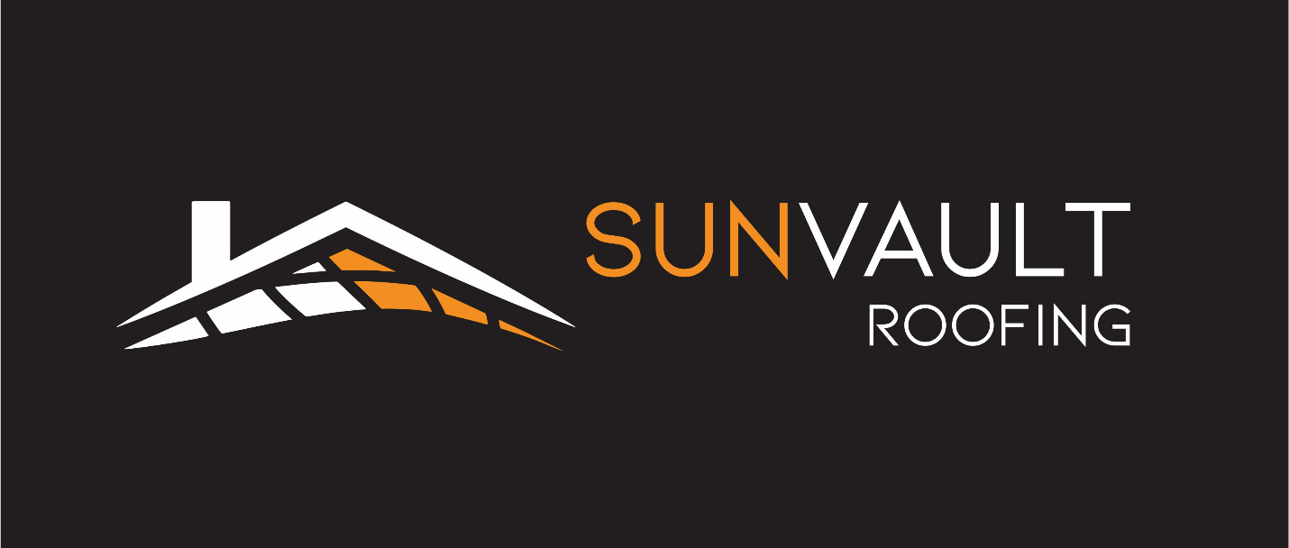
Sun Vault Roofing Unveils Madison’s First Integrated Solar Roof
MADISON, WI — October 8, 2025 — Sun Vault Roofing is proud to announce the successful installation of Madison’s first integrated solar roof, a major milestone in the state’s clean energy journey. Construction was completed at a home on Madison’s west side in September.
As the only certified installer of Solstice solar shingles in Wisconsin, Sun Vault Roofing is pioneering a new era of solar roofing that blends cutting-edge energy technology with superior finesse. Unlike conventional solar panels, Solstice shingles integrate directly into the roofline and attach directly to the roof deck, offering a sleek, modern aesthetic without compromising durability or design.
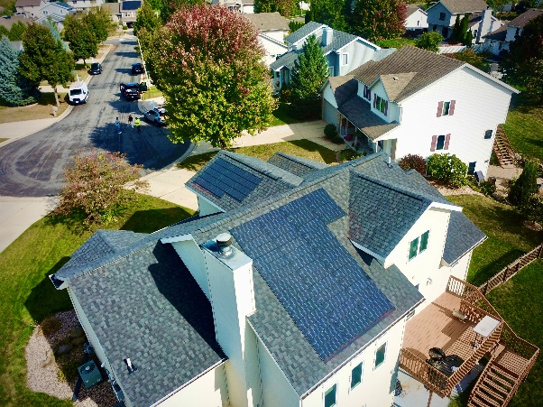
“Solar shingles create clean energy without the trade-offs of conventional panels,” said Jon Torre, co-owner of Sun Vault Roofing. “They maintain clean, modern aesthetics while preserving the integrity of the rooftop—every roofer’s top priority.”
Sun Vault Roofing’s first solar roof installation is just the beginning. The company is currently on track to complete several more solar roofing projects in Madison, Evansville, Sheboygan, Oconomowoc, and Cambridge by the end of the year. These installations will deliver over 52 kilowatts of solar capacity. The environmental benefit of planting roughly 1,200 trees across Wisconsin.
But the impact goes beyond energy output. Thanks to the integrated design of Solstice shingles, these projects will prevent drillign over 1,000 holes in customer rooftops, preserving the watertight integrity of each building’s roof and reducing long-term maintenance risks. For homeowners and business owners alike, this means cleaner installs, fewer leaks, and longer-lasting roofs.
Sun Vault Roofing’s mission is to reimagine the future of roofing by making solar smarter, more accessible, and more beautiful. By popularizing solar shingles, the company aims to drive down costs over time and increase accessibility, just as widespread adoption did for conventional panels in the past decade. This commitment to equity and innovation is central to Sun Vault Roofing’s vision for a more sustainable Wisconsin.
Explore the Future of Roofing
We invite fellow Chamber members and Madison residents to explore the benefits of our solar shingles. Whether you're considering a roof replacement or looking to enhance your property's energy efficiency, our team is here to assist.
Contact Information:
Website: https://sunvaultroofing.com
Email: info@sunvaultroofing.com
Phone: (608) 608-1082
For a free roof inspection or to learn more about our services, please visit our website or reach out directly via email or phone.
