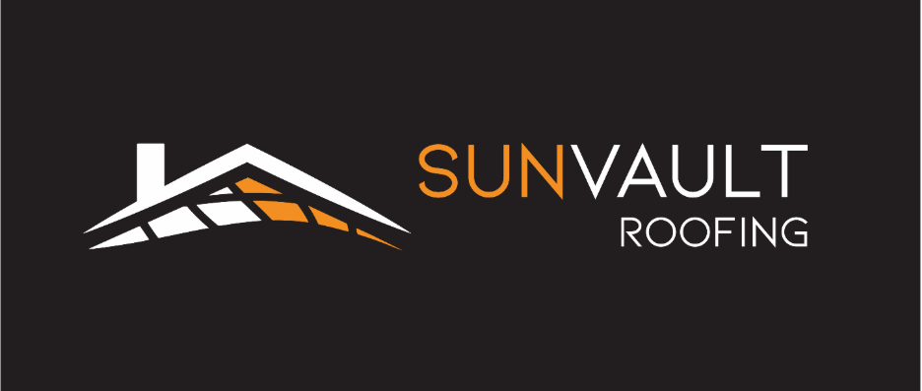
Clean Jobs Midwest Recognizes Mike Mannion of Sun Vault Roofing
Worker profile highlights leadership in integrated solar shingle roofing across Wisconsin
MADISON, WI — October 20, 2025 — Clean Jobs Midwest has featured Sun Vault Roofing co‑founder and Director of Operations Mike Mannion in its Worker Profile series, recognizing his leadership in bringing integrated solar shingle roofing to Wisconsin homeowners.
The profile centers on Mannion’s on‑the‑ground project leadership, from the first customer call through final homeowner walkthrough, along with his hands‑on training and focus on pairing reroofing with clean energy. Thanks to Mike’s leadership, Sun Vault Roofing unveiled Madison’s first integrated solar roof in September 2025. The feature from Clean Jobs Midwest also explains how integrated solar shingles deliver a low‑profile look without bulky racks, helping more Wisconsin homeowners consider solar at the time of roof replacement.
Rather than a one‑off milestone, the recognition speaks to a growing skills base in south‑central Wisconsin and Sun Vault Roofing’s commitment to craftsmanship, code compliance, and homeowner education around integrated solar roofing.
Reimagine the Future of Roofing
Sun Vault Roofing is a Wisconsin contractor specializing in high‑quality asphalt roofing and integrated solar shingle systems. Their mission is to help homeowners protect their homes and power their future with great‑looking, durable roofs.
Sun Vault Roofing invites fellow Chamber members and Madison residents to explore the benefits of integrated solar shingles. Whether you're considering a roof replacement or looking to enhance your plans for new construction, their team is here to assist.
Contact Information:
Website: https://sunvaultroofing.com
Email: info@sunvaultroofing.com
Phone: (608) 608-1082
For a free roof inspection or to learn more about our services, please visit our website or reach out directly via email or phone.
