CONTACT:
Katie Marron
VP of Marketing
North Central Group
kmarron@ncghotels.com
608-698-9051

DoubleTree by Hilton Madison East Opens Its Doors

North Central Group opens its latest hotel with Conference Center and new Restaurant and Bar.

MADISON, Wis. (November 19, 2020) – Today DoubleTree by Hilton Madison East opens its doors to guests. The six story, 226-room hotel, located in Madison, Wisconsin, is the latest addition to the growing DoubleTree by Hilton portfolio, one of Hilton’s 18 market-leading brands.

The hotel features newly designed guest rooms with a spacious, modern feel. In addition, guests can opt to access their room from the palm of their hand with the award-winning Digital Key technology, available through the Hilton Honors mobile app, allowing for a contactless arrival experience. The spacious lobby offers a warm, vibrant décor and features Tailwinds, a new restaurant and bar, Starbucks Café, and Made Market Pantry. The hotel also boasts 9,500 sq. ft. of state-of-the-art meeting and event space, including an elegant 4,600 sq. ft. Crystal Ballroom.

In addition to the above highlights and as a response to the COVID-19 pandemic, DoubleTree by Hilton Madison east is part of the Hilton CleanStay with Lysol Protection Program and Hilton EventReady with CleanStay program to help guests enjoy a clean and safe experience during their stay.

“We are delighted to bring DoubleTree by Hilton’s renowned hospitality and warm welcome to the East side of Madison – bringing to life new opportunities and a destination for travelers and the people of Madison alike,” said Lynette Knutson, General Manager, DoubleTree by Hilton Madison East.

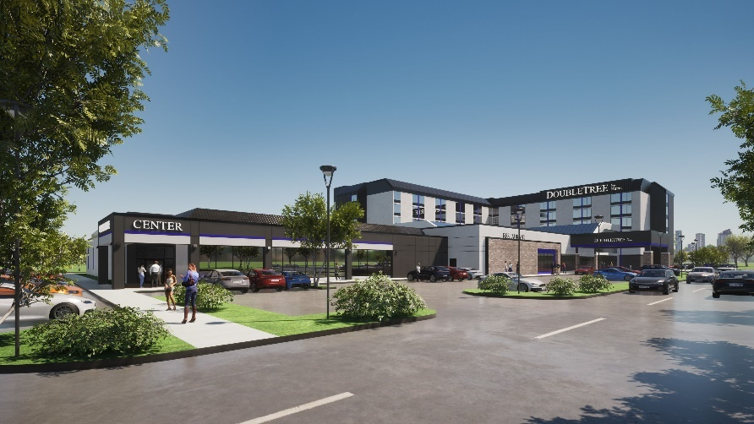

DoubleTree by Hilton Madison East is located at 4402 East Washington Ave. and is the latest project from North Central Group (NCG), a local, family-owned real estate hospitality company. NCG owns and manages nine additional properties in the Madison area and owns the new Liberty Station restaurant.

To celebrate the hotel’s opening around the Holidays, guests can take advantage of several specials available now, such as Santa’s Sweet package, Winter Savings rate, and Virtual School package.

For more information, or to make a reservation and/or book your next event, visit www.doubletreemadisoneast.com, call 608-244-4701, or email doubletreeevents@ncghotels.com.
# # #

About DoubleTree by Hilton
DoubleTree by Hilton is a fast-growing, global portfolio of more than 600 upscale hotels with more than 138,000 rooms across 47 countries. For more than 50 years, DoubleTree by Hilton has continued to be a symbol of comfort for business and leisure travelers around the world, from welcoming guests with its signature warm DoubleTree chocolate chip cookie, to serving the local community. DoubleTree by Hilton offers contemporary accommodations and amenities, including unique food and beverage experiences, state-of-the-art fitness offerings and meetings and events spaces. Hilton Honors members who book directly through preferred Hilton channels have access to instant benefits. To make reservations, travelers may visit doubletree.com. Connect with DoubleTree by Hilton on Facebook, Twitter, and Instagram. Learn about the latest brand news at newsroom.hilton.com/doubletree.

About Hilton
Hilton (NYSE: HLT) is a leading global hospitality company with a portfolio of 18 world-class brands comprising more than 6,300 properties with nearly one million rooms, in 188 countries and territories. Dedicated to fulfilling its mission to be the world’s most hospitable company, Hilton has welcomes more than 3 billion guests in its more than 100-year history, earned a top spot on the 2020 World’s Best Workplaces list, and was named the 2019 Global Industry Leader on the Down Jones sustainability Indices. In 2020, Hilton CleanStay was introduced, bringing an industry-defining standard of cleanliness and disinfection to hotels worldwide. Through the award-winning guest loyalty program Hilton Honors, the more than 110 million members who book directly with Hilton can earn Points for hotel stays and experiences money can’t buy, plus enjoy instant benefits, including contactless check-in with room selection, Digital Key, and Connected Room. Visit newsroom.hilton.com for more information, and connect with Hilton on Facebook, Twitter, LinkedIn, Instagram and YouTube.

About North Central Group (NCG)
Built on enduring principles and an unbridled passion for hospitality, and real estate development, North Central Group® is fa family-owned, Madison, Wisconsin-based owner, developer, and operator of premium hospitality properties. The company operates more than 30 properties across multiple states and national brands. To learn more about NCG and its hospitality properties, visit ncghotels.com. Connect with NCG on Facebook, Instagram, and LinkedIn.

