

FOR IMMEDIATE RELEASE

Big Lift Adds CMO and VP of Sales to its Management Team
Strategic Hires Help Support the Company’s Goals into 2025 and Beyond
Madison, WI (Oct. 16, 2024) – Today, Big Lift, LLC announced the appointment of Martin Boyd as Chief Marketing Officer and Jason Dunigan as Vice President of Sales for its Big Joe and EP North America brands. Dunigan started in his role this week and Boyd will begin in January of 2025. These executive positions will support the company in its many objectives including a strong focus to expand its leadership in lift truck electrification.
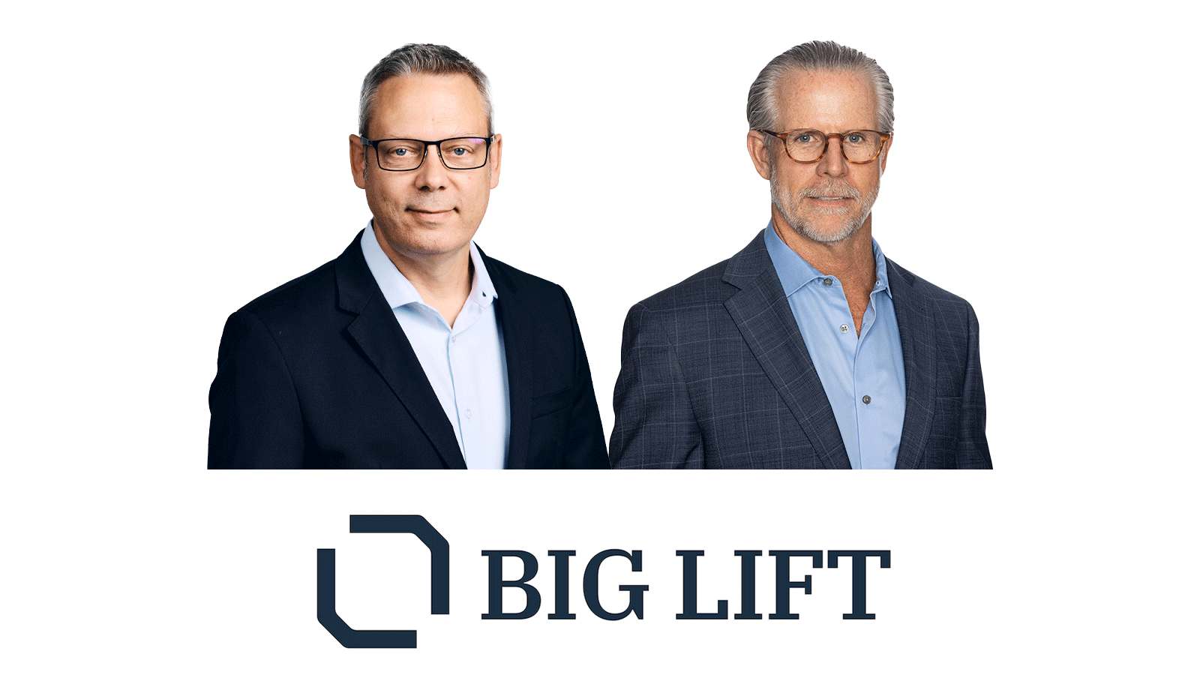
From L to R: Jason Dunigan, VP Sales and Martin Boyd, CMO of Big Lift, LLC

“Big Lift has a clear focus on where our products will best serve our customers moving into 2025 and beyond, and the addition of both Martin and Jason to our team will help us be better positioned for success,” said Dan Rosskamm, President of Big Lift. “As the industry shifts to modernize warehouse equipment, these most recent executive appointments will help us continue to provide cleaner, more efficient technology that makes today’s supply chain run smoothly. We welcome them to the Big Lift brands and look forward to working together for the success of our company.”
With more than 30 years in the material handling industry, Boyd will lead all marketing functions for both brands. Prior to Big Lift, he worked with major OEMs such as Hyster-Yale Group, Cascade Corporation and Toyota Material Handling, holding leadership positions in engineering, technical service, product management and marketing. As Big Lift’s newest addition to the senior executive team, Boyd will utilize his experience to strengthen the Big Joe and EP brands in the North American market. His customer-centric passion will serve to ensure the company’s resources are focused on delivering the right solutions, based on market trends.
As Vice President of Sales for Big Lift, Dunigan will lead the national account and dealer development teams for both brands. He comes to Big Lift with more than 25 years of sales management experience with more than 20 of those focusing on the industrial forklift industry. Dunigan is a US Army Veteran that most recently worked with KION North America where he was instrumental in increasing Linde’s market share in North America by transforming the Key Account Department and developing partnerships with distribution channel partners.

About Big Lift LLC:
Big Lift is a customer-driven North American material handling equipment company, that distributes innovative products and in-between-handling applications, purpose-built counterbalanced lithium forklifts and market-leading autonomous solutions. The company distributes Big Joe and EP brands in North America. Based in Wisconsin, Big Lift provides engineering expertise, customer service, aftermarket parts, and warranty support to the brands it distributes.
# # #
Media Contact:
Kirsten Brundahl
(714) 366-6003
kirsten@masterplancommunications.com
or
Rachel Leadholm
(847) 602-1578
rachel@masterplancommunications.com

