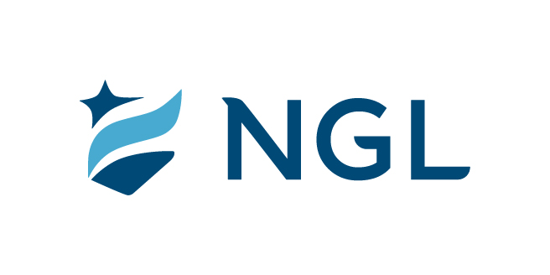

September 13, 2021
For immediate release

Contact: Maria Lubick
mdlubick@nglic.com

Online newsroom: nglic.com/newsroom

NGL announces appointment of Gary Wolter as
incoming Board of Directors Chairman

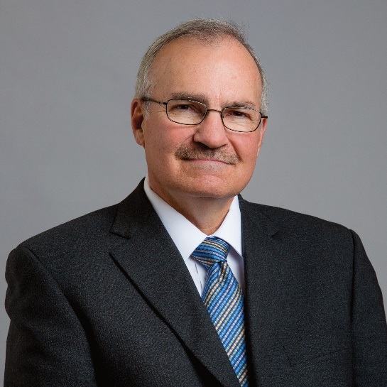
Madison, Wis. (September 13, 2021) – During National Guardian Life Insurance Company’s (NGL) meeting of the Board of Directors on August 12, 2021, it was announced that Gary Wolter is succeeding current Chairman of the Board David Walsh. Walsh has been Chairman since 2017 and has served on the Board of Directors since 1981. Walsh was named Vice Chairman and remains an active member of NGL’s Board of Directors.

“For over forty years David has been an essential member of NGL’s Board. Under his expertise and guidance, we have expanded through acquisitions and focused on growing our core lines of business. On behalf of our Board of Directors, I extend my sincere gratitude to David for his leadership and contributions to NGL’s success,” said Knut Olson, President and CEO of NGL.

Gary Wolter, NGL Board member since 2005, has been appointed the new Chairman of the NGL Board of Directors. Wolter is Chairman Emeritus and retired President and CEO of MGE Energy, Inc. and Madison Gas and Electric Company located in Madison, Wis. Wolter serves, or has served, on numerous community boards throughout the years, including Greater Madison Chamber of Commerce, Madison Community Foundation, MadREP (formerly Thrive), Oscar Rennebohm Foundation, University of Wisconsin Hospital and Clinics, United Way of Dane County, and University of Wisconsin Research Park.

“It’s an honor to be appointed by the Board of Directors as Chairman. I look forward to transitioning into this new capacity as Chairman during a time where NGL is concentrating on growing its business and building awareness of its products that help people meet their unique needs for life’s journey,” said Wolter.

Founded in 1909, NGL is a mutual insurance company that specializes in a suite of innovative insurance products for life’s journey, including individual and group products. Governing NGL includes 14 members on the Board of Directors include Amie Goldman (Chief Strategy Officer, Quartz Health Solutions), Peter Gunder (Venture Partner, American Family Ventures), F. Curtis Hastings (Retired Chairman, J.H. Findorff & Son), Erik Johnson (Chairman and CEO, Hy Cite Enterprises), David Kruger (Chairman and CEO, Fiore Companies), Sherry Manetta (Glenwood Strategies, LLC), Knut Olson (President & CEO, NGL), Daniel Olszewski (Director, Weinert Center for Entrepreneurship at University of Wisconsin-Madison), John Oros (J.C. Flowers & Co), Tammy Roou (Vice President Enterprise Compliance, Northwestern Mutual), David Walsh (Attorney and Retired Partner, Foley & Lardner), Judith Ward (Senior Executive Search Consultant, AGB Search), Gary J. Wolter (Chairman, Retired President & CEO, MGE Energy and Madison Gas and Electric Company), and Elease Wright (Retired Senior Vice President and Chief Human Resources Officer, Aetna, Inc.).

About NGL
Established in 1909 National Guardian Life Insurance Company (NGL) is an insurance company headquartered in Madison, Wis. Licensed to do business in 49 states and the District of Columbia, NGL markets preneed and individual life and annuities, as well as group markets products. Information about NGL can be found at www.nglic.com; Facebook: Facebook.com/NGLIC and LinkedIn: https://www.linkedin.com/company/national-guardian-life-insurance-company.

National Guardian Life Insurance Company is not affiliated with The Guardian Life Insurance Company of America a/k/a The Guardian or Guardian Life.

###

PRBOD92021

