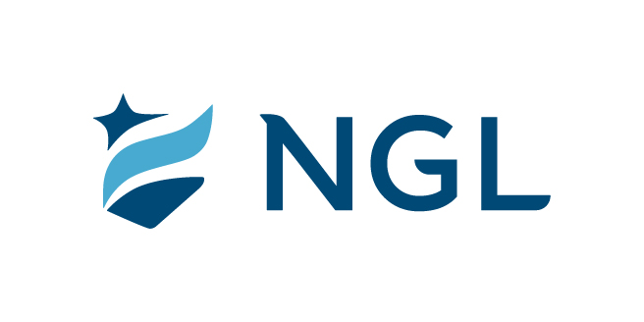
July 6, 2023
For immediate release

Contact: Maria Lubick
mdlubick@nglic.com

Online newsroom: nglic.com/newsroom

Jerie Olson promoted to Vice President, Operations at
National Guardian Life Insurance Company

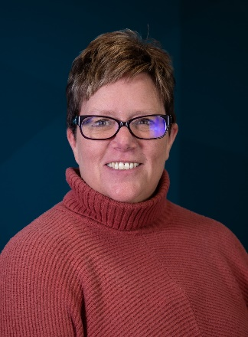
Madison, Wis. (July 6, 2023) – Jerie Olson has been promoted to Vice President, Operations at National Guardian Life Insurance Company (NGL). Olson started at NGL in 1999 and throughout her tenure at the company has worked with a variety of areas supporting our partners and policyholders.

“During my 24 years at NGL I’ve had the opportunity to work closely with and get to know team members across all departments while a member of the Legal/Compliance team. I have always had a close connection and deep appreciation for the Operations team since I work with them daily on issues that impact our customers. They are a wonderful group of people who are collaborative and dedicated to serving our policyholders and helping each other. I look forward to guiding them as they strive to achieve their goals and continuing to support the excellent work, they do each and every day,” said Olson.

In her new role as Vice President, Operations, Olson joins NGL’s Senior Leadership Team as she leads the operations area and end-to-end processes to align with corporate strategies and provide exceptional customer service. Additionally, she will draw on her background in legal and compliance as she manages the operational and workforce risks to ensure NGL processes adhere to industry, regulatory and workplace compliance standards.

“We are excited to have Jerie step into this position at NGL. With over two decades of experience at NGL she is knowledgeable of regulatory requirements, and our processes, as well as is understanding and compassionate when working with policyholders on their needs. I look forward to working with her on enhancing our customer support areas as we grow in the Preneed and AssetGuard spaces and implement a new administration system,” said Kim Shaul, Interim President and CEO at NGL.

Prior to joining NGL, Olson worked in Government Relations for Great Lakes Health Plan in Michigan.

Olson earned her Bachelor of Science degree from the University of Wisconsin-Milwaukee. She lives in DeForest, Wis. with her husband of 27 years and their two dogs. Olson is an avid pickleballer and enjoys spending time on the water kayaking, as well as visiting her daughter in Colorado. Olson also gives back to her community through volunteering and supporting local organizations. She has organized employee fundraising events benefiting United Way of Dane County and is an active member of the Women’s Initiative Network, one of NGL’s Employee Resource Groups.

About NGL
Established in 1909 National Guardian Life Insurance Company (NGL) is an insurance company headquartered in Madison, Wis. Licensed to do business in 49 states and the District of Columbia, NGL markets preneed and individual life and annuities, as well as group markets products. Information about NGL can be found at www.nglic.com; Facebook: Facebook.com/NGLIC and LinkedIn: https://www.linkedin.com/company/national-guardian-life-insurance-company.

National Guardian Life Insurance Company is not affiliated with The Guardian Life Insurance Company of America a/k/a The Guardian or Guardian Life.

###
PRJO72023

