June 21, 2023

For immediate release

Contact: Maria Lubick

[mdlubick@nglic.com](mailto:mdlubick@nglic.com)

Online newsroom: [nglic.com/newsroom](https://www.nglic.com/newsroom)

**Kenn Peterson joins NGL as Vice President, Business and Lending Development**

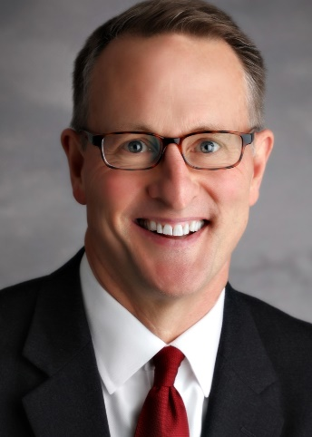Madison, Wis. (June 21, 2023) – National Guardian Life Insurance Company (NGL) is pleased to welcome **Kenn Peterson** to the team as Vice President, Business and Lending Development. Peterson is a leader in the Preneed insurance industry with 36 years of experience helping Preneed companies grow their revenue. In this newly created position, he joins NGL’s leadership team and will be developing a consultative business model, establishing NGL’s lending program and assisting the sales team in achieving company objectives.

“We are thrilled to have Kenn join the team. NGL is dedicated to providing superior service to our partners and focused on continued growth in the industry. After 25 years in Preneed, we understand how to serve our partners and believe in evolving with them to meet their unique needs. Kenn’s new role strengthens our support to our partners and NGL’s commitment to the Preneed industry,” said **Jeremy Ragsdale**, Executive Vice President, Chief Marketing Officer at NGL.

Peterson has held multiple leadership roles, including most recently Vice President, National Sales at Great Western Life Insurance Company, where he and his team helped the company achieve record revenue. Prior to that role he was Regional Director at Homesteaders Life Company for 18 years where he and his team helped the company achieve record growth and revenue.

“NGL is a financially strong company that is known for its commitment to providing a great customer experience and offering valuable products that benefit families. This is an exciting time to join NGL because it’s expanding and focused on the development of future collaborations with partners,” said Peterson. “I’m passionate about Preneed because it’s a solution that helps make the worst day of a family’s life a little easier. I’m honored to work with our partners to find ways that help share the benefits of preplanning. Knowing something that can help those you care about and figuring out the best way to tell them is what motivates me to learn and grow every day.”

Peterson earned his Bachelor of Arts degree from Wittenberg University in Springfield, Ohio, Master of Science Degree from Miami University in Oxford, Ohio and Master of Business Administration from the University of Toledo in Toledo, Ohio. He is a certified Celebrant, Life Tribute Professional, serves on the Cincinnati College of Mortuary Science Board of Trustees, and is a past recipient of the Daniel A. Hillenbrand Award.

**About NGL**

Established in 1909 National Guardian Life Insurance Company (NGL) is an insurance company headquartered in Madison, Wis. Licensed to do business in 49 states and the District of Columbia, NGL markets preneed and individual life and annuities, as well as group markets products. Information about NGL can be found at www.nglic.com; Facebook: Facebook.com/NGLIC and LinkedIn: <https://www.linkedin.com/company/national-guardian-life-insurance-company>.

National Guardian Life Insurance Company is not affiliated with The Guardian Life Insurance Company of America a/k/a The Guardian or Guardian Life.

###

PRKP62023