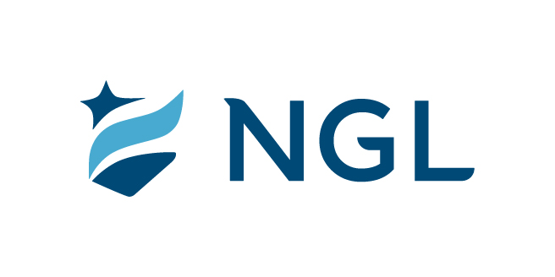
February 1, 2021
For immediate release

Contact: Maria Lubick
mdlubick@nglic.com

Online newsroom: nglic.com/newsroom

History of Black Madison story series by Madison365 sponsored by
National Guardian Life Insurance Company

Madison, Wis. (February 1, 2021) – Through a partnership with Madison365, National Guardian Life Insurance Company (NGL) is sponsoring a series of articles throughout February highlighting notable African Americans in Wisconsin’s past and present.

Sponsoring Madison365’s story series is one of the ways NGL is supporting diversity, equity and inclusion (DEI) not only in the workplace but also throughout the community. NGL is proud to support these critical features on the works and impact of some of Wisconsin’s most prominent Black residents.

“We are fortunate to partner with Madison365, a leading media outlet for people of color in the Midwest, to celebrate Black History Month. This article series is an excellent way to highlight and honor the history of Madison’s Black residents who have made significant contributions to our city since 1839,” said Dave Anderson, NGL Executive Vice President and Chief Operating Officer.

There will be a total of four stories on the history of Black Madison that will be distributed each week during Black History Month featuring:
- The founders of Madison, including John Hill of Hill’s Grocery, Wisconsin Weekly Blade, Free African Methodist Church and first Black University of Wisconsin-Madison graduates.
- Madison’s first Black women highlighting the first Black woman police officer, firefighter, first (and still only) mayor.
- Black educators, including Helen McLean, John Odom, Milt McPike, Geraldine Bernard who impacted the community.
- Influential Black musicians, including Clyde Stubblefield, Richard Davis, Hanah Jon Taylor.

“We are inspired by the creativity and vision of the Madison365 team in developing The History of Black Madison series. NGL is thankful for the for the opportunity to support such rich and important content and storytelling,” said Dwayne Maddox, NGL Marketing Director.

The story series can be found at: Madison365.com.

About NGL
Established in 1909 National Guardian Life Insurance Company (NGL) is an insurance company headquartered in Madison, Wis. Licensed to do business in 49 states and the District of Columbia, NGL markets preneed and individual life and annuities, as well as group markets products. Information about NGL can be found at www.nglic.com; Facebook: Facebook.com/NGLIC and LinkedIn: https://www.linkedin.com/company/national-guardian-life-insurance-company.

National Guardian Life Insurance Company is not affiliated with The Guardian Life Insurance Company of America a/k/a The Guardian or Guardian Life.

###
PRBHM22021

