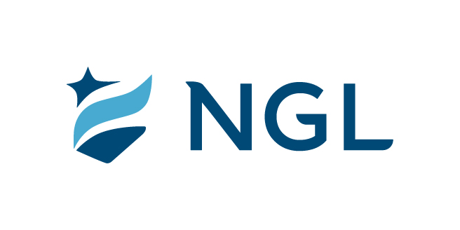
July 5, 2022
For immediate release

Contact: Maria Lubick
mdlubick@nglic.com

Online newsroom: nglic.com/newsroom

Marita LaChapell promoted to Senior Vice President, Chief Administrative Officer

Madison, Wis. (July 5, 2022) – Marita LaChapell has been promoted to Senior Vice President, Chief Administrative Officer at National Guardian Life Insurance Company (NGL). LaChapell joined NGL in January 2020 as Vice President of Internal Consulting.

In her role as Senior Vice President, Chief Administrative Officer she leads the Internal Audit, Procurement and Tax teams. Additionally, LaChapell leads process improvement and process integration projects and has an active role in M&A and many other corporate objectives.

“Marita joined NGL two years ago and her leadership role and impact on the organization has continued to grow. We appreciate her tenacity and efforts that has resulted in lowering our risk profile and improving our professionalism,” said Knut Olson, President & CEO at NGL.


As Founder and CEO of Align Financial, LaChapell has a background and expertise in financial management across a wide variety of industries. In addition, during her 30-year career she broadened her leadership footprint by designing and implementing enterprise/information systems, compensation strategies, advising clients regarding their personal financial planning, growing advisory sales teams and driving organizational change through continuous improvement, Lean, Six Sigma and Operational Excellence programs.

“NGL has been an exciting and energizing step in my career, I appreciate the organization’s willingness to embrace new challenges to enable growth and the great people I get to work with every day,” said LaChapell of her experience.

She holds a Bachelor of Science in Business Administration degree from Michigan Technological University in public accounting, specializing in information systems. She is a Certified Public Accountant and Personal Financial Specialist. Additionally, LaChapell earned a Lean Six Sigma Black Belt in 2009.

She is a global volunteer for Habitat for Humanity International and serves as a Board member for her church.

About NGL
Established in 1909 National Guardian Life Insurance Company (NGL) is an insurance company headquartered in Madison, Wis. Licensed to do business in 49 states and the District of Columbia, NGL markets preneed and individual life and annuities, as well as group markets products. Information about NGL can be found at www.nglic.com; Facebook: Facebook.com/NGLIC and LinkedIn: https://www.linkedin.com/company/national-guardian-life-insurance-company.

National Guardian Life Insurance Company is not affiliated with The Guardian Life Insurance Company of America a/k/a The Guardian or Guardian Life.

###
PRML72022

