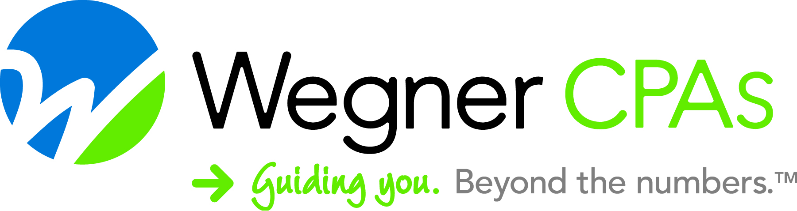

FOR IMMEDIATE RELEASE FMI: Sandy Fischer, 608.442.1920
October 11, 2019 sandy.fischer@wegnercpas.com

Wegner CPAs Receives NASBA Certification for Live and Internet Based Courses
Madison, WI – We received some very exciting news this week. Wegner CPAs has been approved as a registered sponsor on the National Registry of CPE Sponsors for both Group Live courses and Group Internet Based. This status affirms our commitment to the delivery of high quality continuing professional education in compliance with the Statement of Standards for Continuing Professional Education (CPE) Programs (revised August 2016) (Standards) and the program requirements of the National Registry of CPE Sponsors.
What exactly does this mean?

The National Registry of CPE Sponsors was created to help recognize CPE program sponsors who make a commitment to meeting the highest CPE program standards. Only learning providers who are committed to offering high-quality continuing education programs, that improve a CPA’s professional competence, are listed on the Registry. As a NASBA registered CPE provider, we will be able to meet the CPE reporting requirements for more jurisdictions and add value to our client educational offerings. Expanding our registration to include Group Internet Based allows us to offer CPE beyond our borders!
About Wegner CPAs
Headquartered in Madison, WI, Wegner CPAs brings a unique perspective to the practice of accounting and business consulting. The firm specializes in closely held businesses, contractors, cooperatives, manufacturers, nonprofit organizations, and municipalities with a complete range of accounting, audit, tax, and consulting services across the lifecycle of the organization. For more information, visit www.wegnercpas.com or call 888-204-7665.
###

