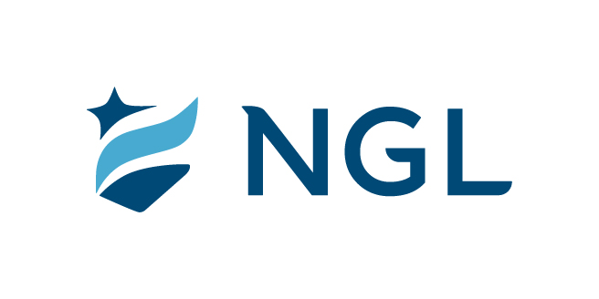
March 30, 2022
For immediate release

Contact: Maria Lubick
mdlubick@nglic.com

Online newsroom: nglic.com/newsroom

Executive promotions announced at National Guardian Life Insurance Company

Madison, Wis. (March 30, 2022) – National Guardian Life Insurance Company (NGL), a Madison-based mutual life insurance company is pleased to announce a number of executive promotions recently approved by the NGL Board of Directors.

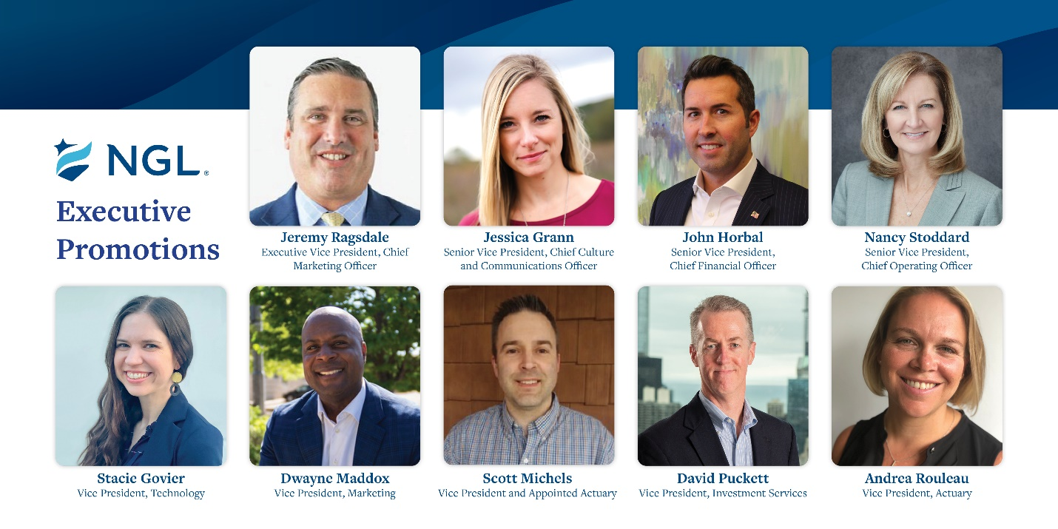

NGL’s Sales, Marketing and Product teams are aligned under Jeremy Ragsdale, who was promoted to Executive Vice President, Chief Marketing Officer. He leads Marketing, Strategic Partner Development, Sales and Business Development, Emerging Markets and Product. Ragsdale has more than 25 years of leadership expertise encompassing all aspects of a life insurance company, including advanced markets, distribution, executive leadership, IT, marketing, new business, operations, product, project and risk. With Ragsdale’s experience he will bring these teams together to strengthen and grow our position in markets where we strive to be number one.

Jessica Grann was promoted to Senior Vice President, Chief Culture and Communications Officer. She has more than 20 years of broad marketing experience encompassing strategic planning, creative design, media planning and purchasing, direct marketing, public relations and sales promotions. Grann focuses on all aspects of the NGL brand as she advances culture through human resources, benefits and payroll, talent development, corporate communications and buildings and grounds.

Taking an expanded leadership role, John Horbal was promoted to Senior Vice President, Chief Financial Officer. Joining NGL in 2020 he has been responsible for leading finance from an accounting, financial planning and analysis and corporate development perspective. Horbal has been instrumental in continuing to build on NGL’s historical financial strength helping to achieve the highest level of capital and surplus in the history of the company and an A (Excellent) rating from AM Best. He is also the Chief Financial Officer of Commercial Travelers Life Insurance Company where NGL launched a dental and vision business “BrightBenefits” and subsequently acquired PrimeCare, LLC. He is approaching 20 years of broad financial management experience with a focus in financial services, insurance and asset management industries at American Express, TIAA, and Foresters Financial. Horbal will continue to lead finance, as well as actuarial and investments as we bring these teams together to support our long-term financial goals.

Nancy Stoddard was promoted to Senior Vice President, Chief Operating Officer. In this role she will lead the information technology and service operations teams. Aligning these areas under Stoddard allows for a clear vision for operational excellence, helps to drive operational efficiencies, and collaboration of strategic initiatives to provide excellent customer service for both internal and external customer needs. Stoddard joined NGL in 2018 as Senior Vice President and Chief Actuary She has 40 years of experience in the insurance industry in various roles including leading Actuarial, Finance and Operations.

Stacie Govier was promoted to Vice President, Technology. Govier spent the past two years leading NGL’s strategic delivery and application development teams and will be expanding her role to include NGL’s infrastructure and help desk teams. Her passion is aligning teams to build better customer-centric solutions, while continuously improving how technology is maintained and supported. She began her career with NGL in 2014 and has more than thirteen years of experience in project and agile delivery.

Dwayne Maddox was promoted to Vice President, Marketing. Maddox manages the day-to-day operations of the marketing team, including the coordination of marketing campaigns and strategies related to NGL’s preneed and specialty insurance products. Maddox has nearly 15 years of insurance experience and strategically aligning culture, purpose and brand while driving product awareness and business growth.

Scott Michels was promoted to Vice President and Appointed Actuary. Michels has 23 years of experience in the financial services industry, primarily as an actuary. In his role Michels directs and manages the valuation area of the actuarial financial reporting team. Additionally, he serves as the Appointed Actuary for the NGL Insurance Group of companies and is responsible for reserve adequacy, asset/liability analysis, valuation, forecasting and other various actuarial related matters.

David Puckett was promoted to Vice President, Investment Services. Puckett joined NGL in 2020 and has 28 years of experience managing insurance company assets. In this role, he works closely with the Chief Investment Officer in managing NGL’s investment portfolios and external manager relationships, as well as providing support for various NGL strategic initiatives.

Andrea Rouleau has been promoted to Vice President, Actuary. In this role, Rouleau oversees all new product pricing, product development, and in force management. She will continue to collaborate with the service operations, legal/compliance, and marketing/sales teams to set and implement product strategy. Additionally, she serves as the Illustration Actuary for NGL. Rouleau joined NGL in 2011 and has nearly 18 years of insurance experience that includes pricing, product development, in force management, sales, distribution and marketing in a variety of life, annuity, and health products.

About NGL
Established in 1909 National Guardian Life Insurance Company (NGL) is an insurance company headquartered in Madison, Wis. Licensed to do business in 49 states and the District of Columbia, NGL markets preneed and individual life and annuities, as well as group markets products. Information about NGL can be found at www.nglic.com; Facebook: Facebook.com/NGLIC and LinkedIn: https://www.linkedin.com/company/national-guardian-life-insurance-company.

Ratings current as of 3/24/21. National Guardian Life Insurance Company is not affiliated with The Guardian Life Insurance Company of America a/k/a The Guardian or Guardian Life.

###
PREP32022

