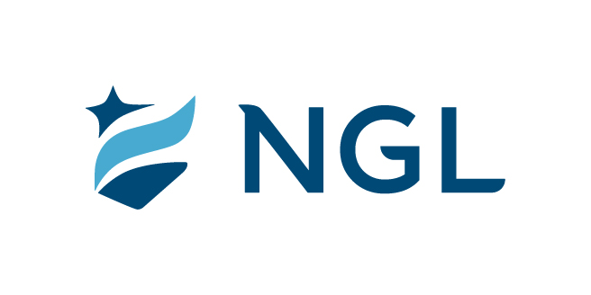
July 25, 2022
For immediate release

Contact: Maria Lubick
mdlubick@nglic.com

Online newsroom: nglic.com/newsroom

National Guardian Life Insurance Company sells
Settlers Life Insurance Company

Madison, Wis. (July 25, 2022) – National Guardian Life Insurance Company (NGL), a Madison-based mutual life insurance company, announced the sale of Settlers Life Insurance Company, a Wisconsin domiciled insurer, to Everly Holdings, LLC, the owner of Everly, LLC, a direct-to-consumer insurance agency.

Approximately 225,000 policies that are geographically disbursed throughout the United States consisting of final expense and single premium immediate annuity are included in the agreement.

“This sale resulted in NGL reaching historical levels of capital, giving the company unprecedented financial strength. The transaction further positions NGL to grow in the Preneed insurance industry and will allow us to enhance our digital capabilities to serve funeral homes and their customers in new ways,” said Knut Olson, President & CEO of NGL.

“We’re excited to acquire Settlers Life and believe it will further enable Everly to execute on its mission of providing direct and digital access to high quality and affordable life insurance products,” said Doug Wolff, Chairman of Everly Holdings, LLC. “It was a pleasure working with Knut Olson and the entire NGL management team in bringing this transaction to close.”
Olson continued, “We greatly appreciate the hard work and dedication from both teams as we work to close this transaction and ensure a successful transition.”
About Everly
Everly was founded by industry veterans who are passionate about the vital role that life insurance can play in all of our lives. Everly’s vision is to modernize the industry by providing a next-generation solution, using all the advantages that life insurance can provide to empower people to live confidently.

About NGL
Established in 1909 National Guardian Life Insurance Company (NGL) is an insurance company headquartered in Madison, Wis. Licensed to do business in 49 states and the District of Columbia, NGL markets preneed and individual life and annuities, as well as group markets products. Information about NGL can be found at www.nglic.com; Facebook: Facebook.com/NGLIC and LinkedIn: https://www.linkedin.com/company/national-guardian-life-insurance-company.

National Guardian Life Insurance Company is not affiliated with The Guardian Life Insurance Company of America a/k/a The Guardian or Guardian Life.

###
PRSLS72022

