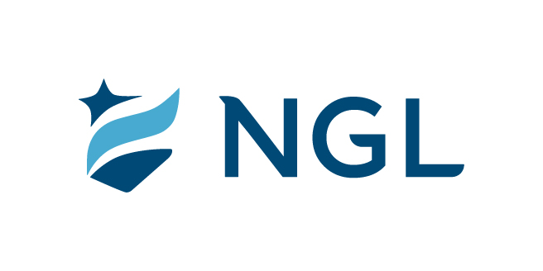
October 20, 2023
For immediate release

Contact: Maria Lubick
mdlubick@nglic.com

Online newsroom: nglic.com/newsroom

National Guardian Life Insurance Company named Best Places to Work 2023

Madison, Wis. (October 20, 2023) – National Guardian Life Insurance Company (NGL) has been recognized as one of the Best Places to Work 2023 by Madison Magazine.

The Best Places to Work award is based on an employee engagement survey administered by Quantum Workplace, a third-party human resources technology provider that measures employee feedback on six key areas: communication and resources, individual needs, manager effectiveness, personal engagement, team dynamics and trust in leadership.

“We are honored and excited to be named as one of the Best Places to Work in the Madison area. NGL is a great place to work because of our employees, culture and mission to be there when others need us,” said Kim Shaul, Interim President & CEO at NGL. “Our employees are dependable, compassionate people who are dedicated to supporting funeral homes in their mission to serve families. When families are grieving and focused on celebrating the life of their loved one, having a prearranged funeral funded through an NGL whole life policy removes the financial burden of funeral expenses and offers peace of mind.”

According to Quantum Workplace, the Best Places to Work survey is administered annually and honors superior organizations where voices are heard, cultures are thriving and employees are engaged. The Best Places to Work award is given to the top 10 businesses in the size categories of small, medium and large, with the placement on the list determined by survey results.

“Employees tell us NGL is a great place to work because of the people and the benefits provided. Continuous feedback is encouraged and helps us better understand employee needs and thoughts. We’re committed to listening and turning feedback into actionable items by evolving policies and initiatives impacting our employees,” shared Jessica Grann, Senior Vice President and Chief Culture and Communications Officer at NGL. “We remain focused on enhancing and improving areas that are important to our employees. We strive to create an environment where employees can bring their whole, authentic selves to work through our diversity, equity and inclusion efforts.”

NGL is a life and health insurance company specializing in individual and group products. We offer a suite of innovative insurance products for life’s journey, giving our customers the financial stability, careful guidance and peace of mind to lead a life filled with confidence, dignity and grace. With nearly 115 years in the industry, we take pride in being there for our customers when they need it most.

About NGL
Established in 1909 National Guardian Life Insurance Company (NGL) is an insurance company headquartered in Madison, Wis. Licensed to do business in 49 states and the District of Columbia, NGL markets preneed and individual life and annuities, as well as group markets products. Information about NGL can be found at www.nglic.com; Facebook: Facebook.com/NGLIC and LinkedIn: https://www.linkedin.com/company/national-guardian-life-insurance-company.

National Guardian Life Insurance Company is not affiliated with The Guardian Life Insurance Company of America a/k/a The Guardian or Guardian Life.

###
PRBPW102023

