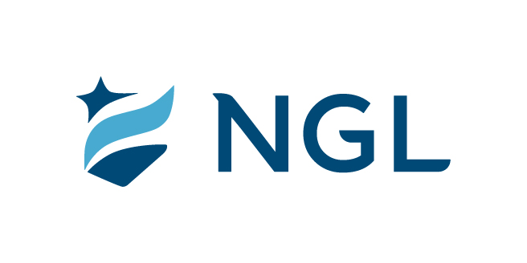
August 19, 2022
For immediate release

Contact: Maria Lubick
mdlubick@nglic.com

Online newsroom: nglic.com/newsroom

National Guardian Life Insurance Company Sponsors the
2022 Conference of African American Financial Professionals

Madison, Wis. (August 19, 2022) – National Guardian Life Insurance Company (NGL) is pleased to be a Platinum Sponsor of the 16th Annual Conference of African American Financial Professionals (CAAFP) held in Washington, D.C. This is the third consecutive year NGL has sponsored the event with it being the first time NGL employees were able to attend in-person since the pandemic began. Hosted by The American College of Financial Services, the conference was August 8-10 and is the largest gathering of African American financial professionals that provides an opportunity for education, networking, and engagement.

“The CAAFP was one of the best conferences I have attended,” shared Christin Blotz, Talent Development & DEI Partner at NGL. “At NGL, we are committed to supporting diversity, equity and inclusion and we are proud to be an ally and help foster change in the financial services industry that create opportunities and lead to economic empowerment for Black communities.”

In addition to attending the conference, Blotz introduced keynote speakers, George Nichols, President & CEO of The American College of Financial Services and Jacob Pruitt, President of Fidelity Charitable. During their keynote session they highlight family inspiration and values, philanthropy, and business and community leadership.

About NGL
Established in 1909 National Guardian Life Insurance Company (NGL) is an insurance company headquartered in Madison, Wis. Licensed to do business in 49 states and the District of Columbia, NGL markets preneed and individual life and annuities, as well as group markets products. Information about NGL can be found at www.nglic.com; Facebook: Facebook.com/NGLIC and LinkedIn: https://www.linkedin.com/company/national-guardian-life-insurance-company.

National Guardian Life Insurance Company is not affiliated with The Guardian Life Insurance Company of America a/k/a The Guardian or Guardian Life.

###
PRCAAFP82022

