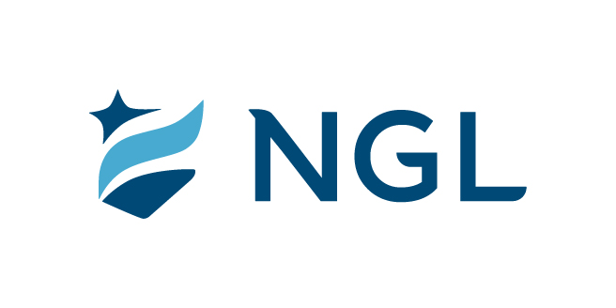
January 24, 2024
For immediate release

Contact: Maria Lubick
mdlubick@nglic.com

Online newsroom: nglic.com/newsroom

Nominations now open for the second annual Inspiration Award

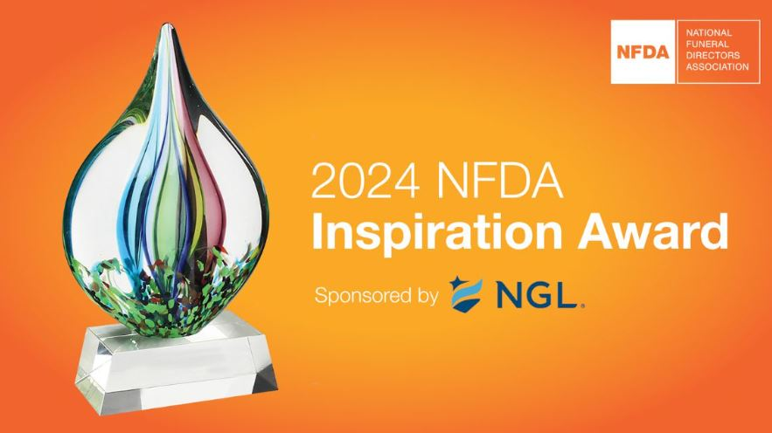
Madison, Wis. (January 24, 2024) – Following a motivational inaugural year, National Guardian Life Insurance Company (NGL) is pleased to once again sponsor National Funeral Directors Association’s (NFDA) second annual Inspiration Award. Nominations are now open with NFDA accepting submissions through February 16 in recognition of an exceptional woman who has made noteworthy professional contributions to the funeral service industry or related fields.

“I’m excited and honored to be part of the annual Inspiration Award through NGL’s sponsorship. There are many outstanding women in the profession who deserve to be recognized for their successes and have their story shared. I look forward to learning who the next exceptional female that has elevated the funeral service will be,” said Jennifer Kaset, Vice President, Sales and Business Development at NGL.

The 2024 Inspiration Award recipient will be announced during the 2024 Professional Women’s Conference in Savannah, Ga, April 28-30, 2024.

Last year, Kaset had the privilege of presenting the 2023 NFDA Inspiration Award to Ellen Wynn McBrayer. Ellen is a licensed Funeral Director/Embalmer, Certified Celebrant, Certified Funeral Service Practitioner, Certified Preplanning Consultant and is the President and Chief Financial Officer of Jones-Wynn Funeral Homes and Crematory, a third-generation family business.

Click here to learn more, including criteria and guidelines about the NFDA 2024 Inspiration Award.

About NGL
Established in 1909 National Guardian Life Insurance Company (NGL) is an insurance company headquartered in Madison, Wis. Licensed to do business in 49 states and the District of Columbia, NGL markets preneed and individual life and annuities, as well as group markets products. Information about NGL can be found at www.nglic.com; Facebook: Facebook.com/NGLIC and LinkedIn: https://www.linkedin.com/company/national-guardian-life-insurance-company.

National Guardian Life Insurance Company is not affiliated with The Guardian Life Insurance Company of America a/k/a The Guardian or Guardian Life.

###
PRNFDAIA12024

