FOR IMMEDIATE RELEASE

Contact: Gail Shore (612) 770-4106
Shore to Shore Communications, Inc.
gshore@winternet.com

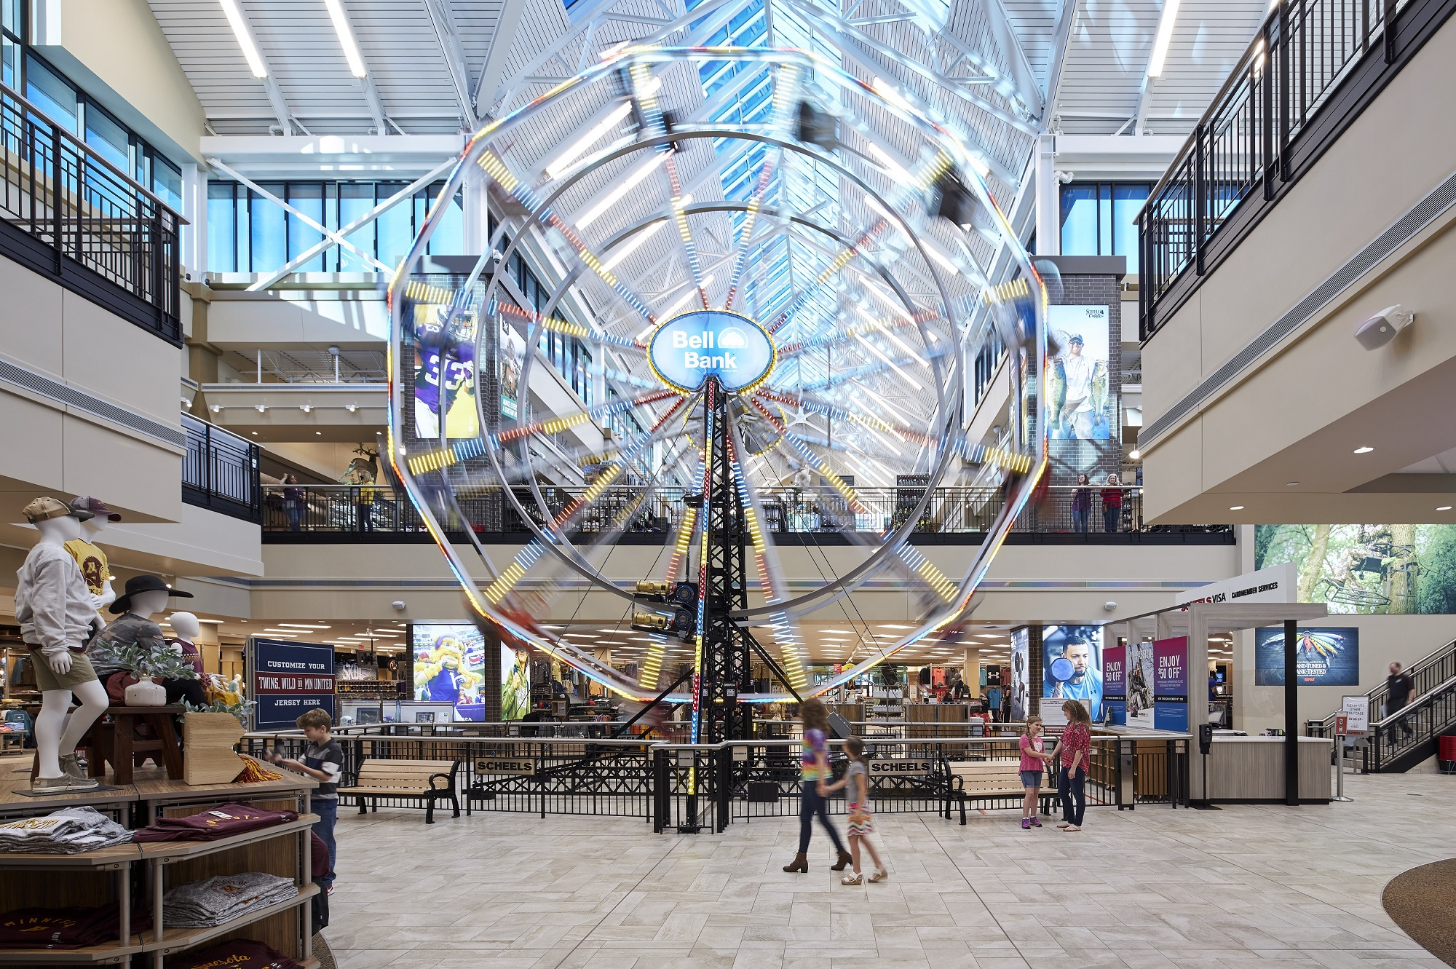
Kraus-Anderson’s Scheels store wins two awards for
outstanding projects in retail real estate and development

EDEN PRAIRIE, Minn. (December 2020) – Scheels retail sporting goods store has been recognized with two STARR Awards for outstanding projects in retail real estate and development from the Minnesota Shopping Center Association (MSCA).

The 250,000-square-foot located at the Eden Prairie Center in Eden Prairie, Minn. was honored in two categories: New Retail Construction over 20,000 square feet; and Retail Redevelopment over 10,000 square feet.

Built by the Madison office of Kraus-Anderson and designed by R.L. Engebretson Architecture, the $58 million store consists of two main stories of retail space with a 16,000-gallon saltwater aquarium, 45-foot-tall Ferris Wheel, wildlife taxidermy mountain, as well as a restaurant, candy shop and offices.

The new store also features a world-class golf shop, bike shop, ski shop, canoe and kayak shop, fishing shop, and gun and hunting shops. Ginna’s Café and Fuzziwig’s Candy Factory will serve gourmet soups and sandwiches, coffee and specialty drinks, and 24 flavors of homemade fudge.

About Kraus-Anderson
Established in 1897, Kraus-Anderson® Construction Company (www.krausanderson.com) is one
of the nation’s premier commercial general contractors and construction managers. Kraus-Anderson,
an Affirmative Action, Equal Employment Opportunity Employer, is headquartered in Minneapolis, Minn. and has regional offices in Madison, Wis., Bismarck, N.D., and Duluth, Bemidji and Rochester Minn.
###

