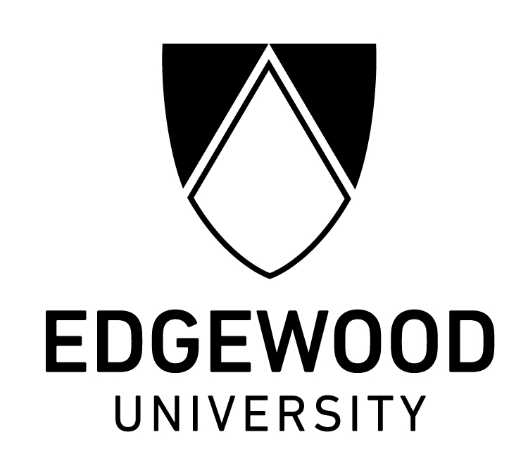

New Name, Same Mission

FOR IMMEDIATE RELEASE Contact: Ed Taylor, Chief of Staff 608-663-2333

Madison, Wis. (July 1, 2025) – Edgewood University proudly raised the new flag above campus for the first time at a brief ceremony this morning.

“In January of this year, we announced that Edgewood College will be renamed Edgewood University. That day has now arrived,” President Manion, said. “The change comes about as we approach our centennial year, and as we continue to expand the reach of our mission as a Catholic institution of higher education in the Dominican tradition.”

The President spoke to an energized group of students, faculty, staff, and several Dominican Sisters of Sinsinawa – the sponsoring order of Edgewood University.

Edgewood University has been effectively operating as a university since 1986, when Master of Science and Master of Arts degrees including Business Administration, Education, and Religious Studies were added to the academic portfolio. In 2001, the Doctoral Degree in Educational Leadership was added. Since that time, the Doctor of Nursing Practice degree and the Doctor of Business Administration have been added. The newest doctoral programs, the Doctor of Occupational Therapy, and the Doctor of Nursing Practice – Nurse Anesthesia, will welcome their first cohorts of students in Fall 2025.

Institutional partnerships and strategic use of technology are fueling significant enrollment growth. As of 2025, Edgewood University is now home to more than 1,300 graduate students from the U.S. and 37 other countries.

About Edgewood University
Located in Madison, Wis., Edgewood University is a comprehensive, Catholic university in the Dominican tradition. We serve approximately 2,500 undergraduate and graduate students. Edgewood University offers more than 40 academic and professional programs, including master’s degrees in business, education, and nursing, and doctoral degrees in educational leadership, nursing practice, and business administration. Edgewood University is a member of the Wisconsin Association of Independent Colleges and Universities and the National Collegiate Athletics Association and is accredited by the Higher Learning Commission. For more information about Edgewood University, please visit www.edgewood.edu, or call Ed Taylor at 608-663-2333.

###

