May 12, 2020

For immediate release

Contact: Maria Lubick

608.443.5284

[mdlubick@nglic.com](mailto:mdlubick@nglic.com)

Online newsroom: [nglic.com/newsroom](https://www.nglic.com/newsroom)

**New logo and brand revealed at National Guardian Life Insurance Company**

Madison, Wis. (May 12, 2020) – National Guardian Life Insurance Company (NGL) has always been a creator of connection and promoter of people.

“For more than a century NGL has been a leader in the insurance industry. We believe in providing insurance solutions that link people to the right products and partners for life’s journey. Our purpose is to help people face life’s financial challenges with confidence, dignity and grace,” said **Jessica Grann**, NGL Chief of Staff and Vice President of Brand and Corporate Communications.

**Greater focus and new purpose**

NGL has utilized the “tree of life” logo since 1965 when it was originally created. It has been a strong logo, however with NGL’s renewed purpose and focus, a modern brand that resonated with partners and policyholders was created.

Several logos were developed and tested using Implicit Association Testing to determine which logos appeared to be more reliable, inviting, authentic, experienced and innovative. After additional testing by agents and policyholders, NGL’s new logo was selected.

“Testing several logos and selecting one that represents NGL’s values has been a valuable process. We chose a logo and messaging that promotes the ideas and values of NGL as a reliable, trustworthy leader who will be there for partners, policyholders and employees when they need it most,” said **Jessica Grann**, NGL Chief of Staff and Vice President of Brand and Corporate Communications.

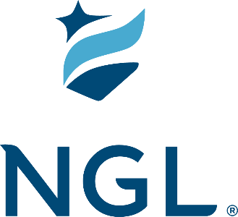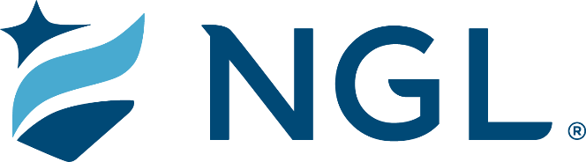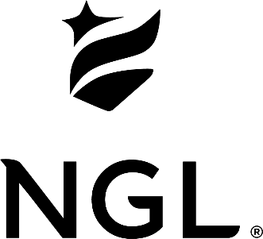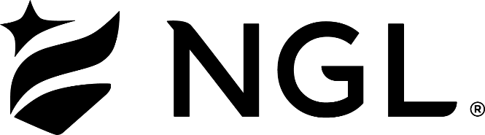

Throughout the upcoming year NGL will update its digital platforms, marketing materials, applications and building signage.

NGL’s branding and messaging may be changing but that doesn’t mean the company is abandoning its heritage. NGL is writing the next chapter in its story - a chapter that builds on the company’s promises, strengths and innovation.

**About NGL**

Established in 1909 National Guardian Life Insurance Company (NGL) is an insurance company headquartered in Madison, Wis. Licensed to do business in 49 states and the District of Columbia, NGL markets preneed and individual life and annuities, as well as group markets products. Information about NGL can be found at www.nglic.com; Facebook: Facebook.com/NGLIC and LinkedIn: <https://www.linkedin.com/company/national-guardian-life-insurance-company>.

National Guardian Life Insurance Company is not affiliated with The Guardian Life Insurance Company of America a/k/a The Guardian or Guardian Life.

###

PRB52020