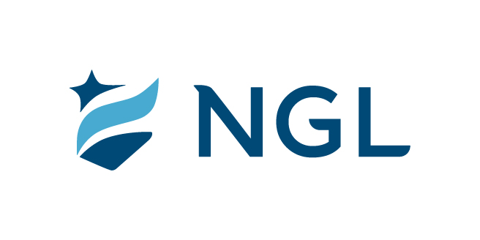
February 8, 2022
For immediate release

Contact: Maria Lubick
mdlubick@nglic.com

Online newsroom: nglic.com/newsroom

Partnership creates custom artwork installation focused on diversity

NGL partners with Hip Hop Architecture Camp for one-of-a-kind display

Madison, WI (February 8, 2022) – With the majority of its employees working remote for nearly two years, National Guardian Life Insurance Company (NGL) used the opportunity to refresh its 58-year-old headquarters, located blocks from the capitol. In 2020 NGL approached Michael Ford, an award-winning, licensed architect and owner of BrandNu Design, a multidisciplinary design firm focused on architecture, fashion, and education with an opportunity to partner on a custom artwork installation for its remodeled lobby.

“We aligned on the most prominent space at the main entrance in our lobby for Michael to develop a concept using NGL’s diversity, equity and inclusion pledge. Michael took our commitment to DEI and incorporated his design process which converts lyrics into textiles,” said Dwayne Maddox, Assistant Vice President, Marketing & Inclusion Experience at NGL.

Ford, known as The Hip Hop Architect, designed a one-of-a-kind two-story stone piece that embodies NGL’s commitment to diversity, equity and inclusion as an integral part of its mission, vision and values.

“This project is important to me because it is the first built project which incorporates my process for mathematically deconstructing words and reconstructing those sonic experiences into something physically tangible such as textiles. On a bigger scale, this project is important because of the fact it’s a statement about diversity and inclusion,” said Ford.

NGL’s DEI statement: “Valuing diversity of thought, background and beliefs are key to living our cultural values of integrity, dependability, collaboration, compassion, and growth. It’s vital to our promise of helping customers face life’s challenges with confidence, dignity and grace. We strive to create an environment free of racism, discrimination, and intolerance – fostering equal opportunities and promoting belonging and inclusion.”

The Text[Tile] wall takes NGL’s words and literally cast them in stone. Ford describes the project as modern-day hieroglyphics. Ford started by deconstructing the statement letter by letter, using a process he created which converts music lyrics into architecture based on syllable counts, rhyme schemes, and other mathematical information which can be extracted from text. The reconstructed statement is made letter by letter and word by word as a series of stone tiles representing each letter in the text. Hence the project name, Text[Tiles].

“When we started transforming our office building, we knew our lobby should serve as a community space. Our goal was to create a modern, welcoming environment where everyone felt comfortable and a sense of belonging. Michael Ford’s artwork visually showcases NGL’s commitment to supporting DEI initiatives in our workplace, community and the insurance industry. The artwork is intentionally placed in the lobby because that’s where it can be the most impactful and appreciated by employees and the community,” said Knut Olson, NGL President & CEO.

NGL and Ford view the project’s value as adding to the Madison community and beyond. “The value of this project goes beyond the physical installation. This collaboration allows for me, a Black architect in Madison to display a unique approach to design while also celebrating other Black architects throughout the state,” said Ford. “Currently, less than two percent of licensed architects are Black. In Wisconsin, there are a total of 12 licensed Black architects. This project will allow the Madison community, which is seeing significant growth and building to discover the Black architects and assist organizations in acting on some of the diversity and inclusion statements and statements of solidarity made throughout these past few years.”

“Connecting and collaborating have been a priority for NGL throughout our 113-year history. During the last couple of years, we’ve been on a journey to reexamine, enhance and incorporate our DEI initiatives into our corporate culture. At NGL we believe it is our obligation and duty to ensure everyone feels a sense of belonging, respect and equitable treatment. We want each of our employees to bring their full, authentic selves to work each day. Our goal is to make everyone feel comfortable, accepted and valued for their unique life experiences and viewpoints,” said Jessica Grann, Vice President, Chief Culture and Communications Officer.

NGL anticipates the installation to be completed by its May 2022 building reopening.

About NGL
Established in 1909 National Guardian Life Insurance Company (NGL) is an insurance company headquartered in Madison, Wis. Licensed to do business in 49 states and the District of Columbia, NGL markets preneed and individual life and annuities, as well as group markets products. Information about NGL can be found at www.nglic.com; Facebook: Facebook.com/NGLIC and LinkedIn: https://www.linkedin.com/company/national-guardian-life-insurance-company.

National Guardian Life Insurance Company is not affiliated with The Guardian Life Insurance Company of America a/k/a The Guardian or Guardian Life.

###
PRBHM22022

