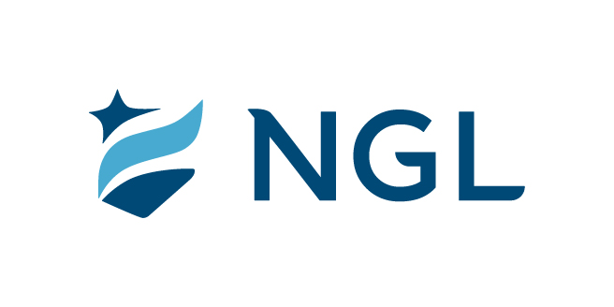
January 25, 2023
For immediate release

Contact: Maria Lubick
mdlubick@nglic.com

Online newsroom: nglic.com/newsroom

Nearly 26,000 meals donated by NGL to fight hunger

Donations for Share Your Holidays campaign benefit Second Harvest Foodbank

Madison, Wis. (January 25, 2023) – National Guardian Life Insurance Company (NGL) proudly supported the 27th Annual NBC15 Share Your Holidays to eliminate hunger campaign to benefit Second Harvest Foodbank of Southern Wisconsin. The food/fund drive campaign helped raise 5.37 million meals surpassing its goal of 5 million meals.

NGL’s $10,000 Bronze sponsorship provided 25,000 meals for people who are struggling with hunger in our community. In addition to NGL’s corporate sponsorship, three of NGL’s team members volunteered during the Grand Finale Phone-A-Thon and seven team members volunteered for the Sort-A-Thon on December 14. Including the volunteer value time, NGL’s commitment to help those facing hunger meant nearly 26,000 meals were donated! The impact means that 23 people in our community will be fed for more than a year.

“We are grateful to support Second Harvest Foodbank and proud to be part of the positive impact they are making in our community. The unfortunate reality is that all area food banks are experiencing an increase in demand for food assistance. Second Harvest helps fill a crucial role for people who are facing hunger. At NGL, we believe everyone should have access to healthful, nutritious foods and that no one should feel hunger or worry where their next meal will come from,” said Maria Lubick, Assistant Vice President, Corporate Communications & Community Engagement at NGL.

For every $10 donation Second Harvest Foodbank of Southern Wisconsin is able to provide up to 25 meals to adults, children and seniors who are struggling with hunger.

About Second Harvest Foodbank of Southern Wisconsin
Second Harvest Foodbank of Southern Wisconsin, southwestern Wisconsin’s largest hunger relief organization, is a nonprofit that is committed to ending hunger in 16 southwestern Wisconsin counties through community partnerships. Learn more at: www.secondharvestmadison.org.

About NGL
Established in 1909 National Guardian Life Insurance Company (NGL) is an insurance company headquartered in Madison, Wis. Licensed to do business in 49 states and the District of Columbia, NGL markets preneed and individual life and annuities, as well as group markets products. Information about NGL can be found at www.nglic.com; Facebook: Facebook.com/NGLIC and LinkedIn: https://www.linkedin.com/company/national-guardian-life-insurance-company.

National Guardian Life Insurance Company is not affiliated with The Guardian Life Insurance Company of America a/k/a The Guardian or Guardian Life.

###
CISYH12023

