Strang Press Release

811 E. Washington Ave. Suite 200

Madison, WI 53703

608.276.9200

strang-inc.com

# 

# Strang Madison Office Awarded WELL Gold Certification

First WELL Certified Space in Wisconsin!

The architectural, engineering, and interior design firm Strang announced today that their Madison office has been awarded the first WELL Gold Certified project in the state of Wisconsin.

This prestigious distinction was awarded through the International WELL Building Institute’s WELL Building Standard™ (WELL), a performance-based certification system for measuring features of the built environment that impact human health and wellbeing. Strang’s office earned this recognition based on seven categories of building performance— Air, Water, Light, Nourishment, Fitness, Comfort, and Mind.

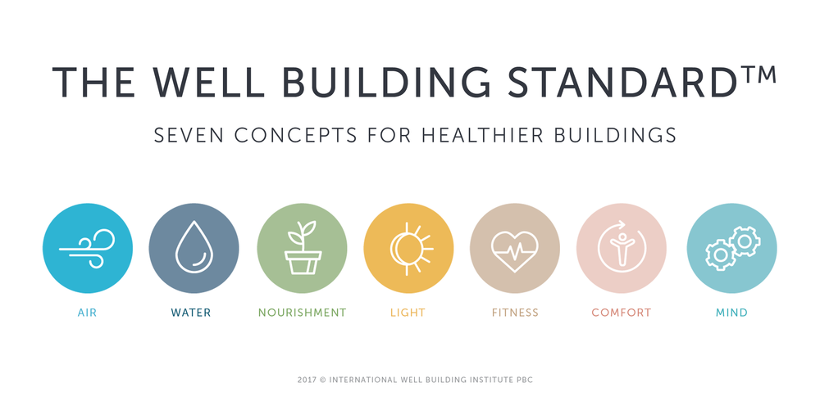

This 8,730 SF office space, which also recently achieved LEED® Gold certification, implemented some of the following practices to achieve a WELL Certified™ Gold rating including: installing specialized HVAC systems to improve indoor air quality, offering quality filtration on drinking water, providing employees with healthy food options, acoustic planning, and designing spaces that promote mindfulness, physical activity, and employee comfort.

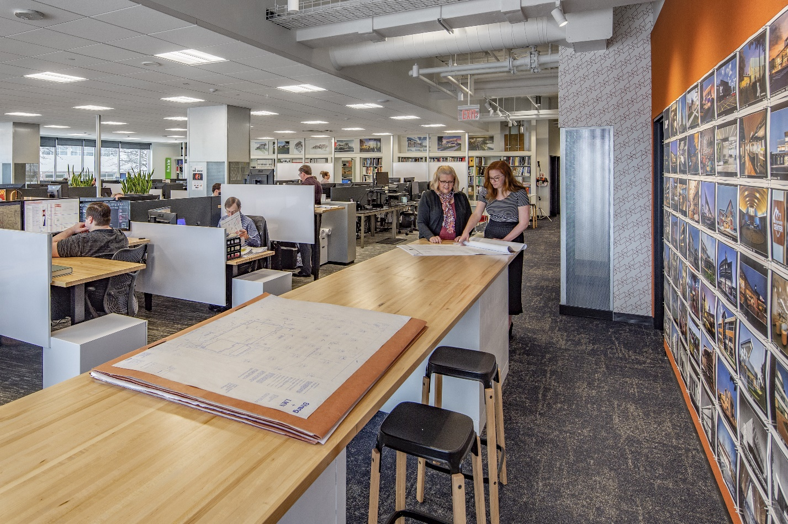

Katie Lowery, Director of Integrated Controls Systems, championed this project to ensure this space met all WELL Gold performance requirements.

**“I’m so proud of our firm and design team to have achieved the first WELL Certified project in the State of Wisconsin! As a culture, we spend 90% of our time indoors and so it’s truly meaningful that our place of work contributes positively to our health. The WELL Building Design Standard has raised the bar on what it means to have a healthy workplace, both physically and mentally. Today’s climate has raised many concerns about maintaining health and our staff has the assurance that we are placing occupant health and well-being as a top priority through our design standards and operations. We’re happy to have done what’s right for our own workplace and are even more excited to share our knowledge with clients who wish to do the same for theirs.”**

**– Katie Lowery, LEED AP, BD-C, WELL AP**

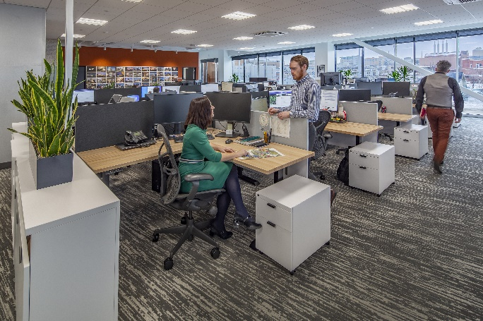 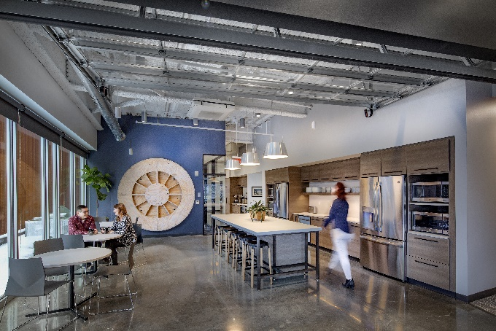

Strang has been a leading practitioner of WELL™ designed facilities, continually seeking out ways in which we can transform our buildings and communities to empower us to live healthier, safer, and more productive lives. It is a great honor to be recognized for our efforts within our own Madison offices and demonstrate how Strang provides thoughtful design centered around health and wellness in the built environment.

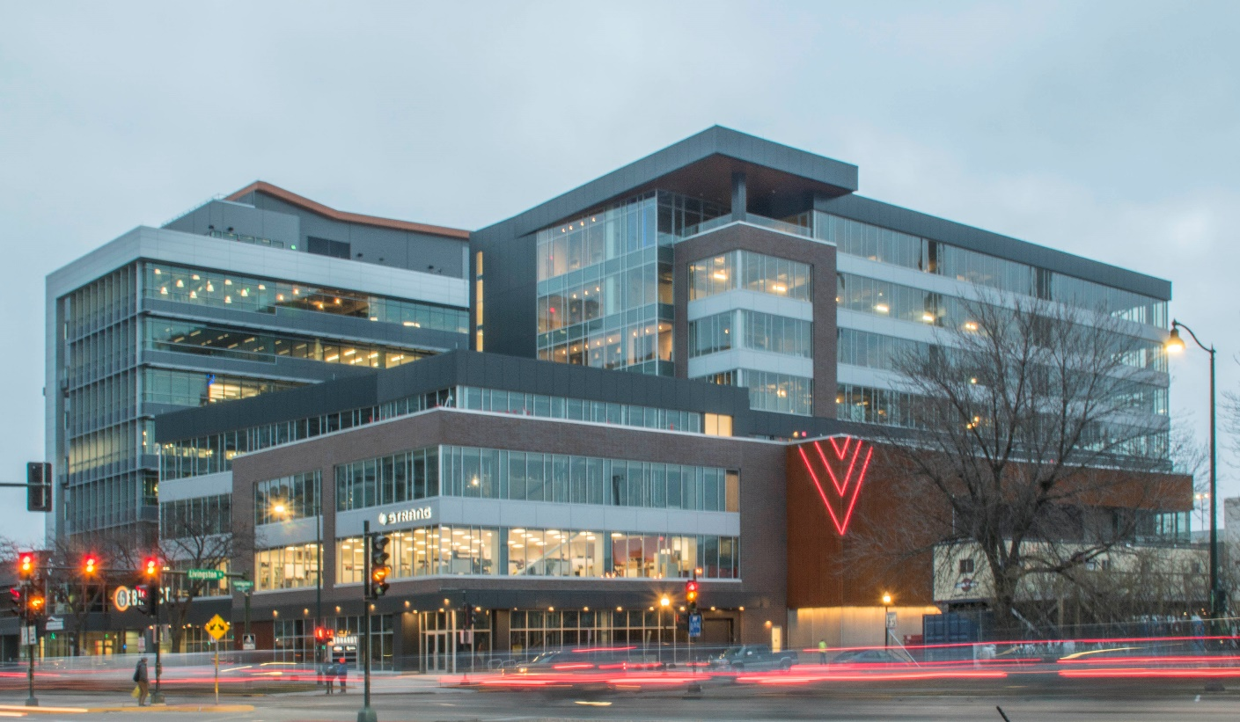

About Strang

Established in 1935, Strang is an award-winning architecture, engineering, and interior design firm with offices in Madison and Waukesha. Our inclusive project approach allows us to provide exceptional design for the most unique and challenging projects within the science and technology, commercial, higher education and civic + cultural sectors.

Check out our blog post and video on this topic as well:

Blog: <https://strang-inc.com/2020/11/20/strang-madison-office-achieves-well-gold-certification/>

Video: <https://www.youtube.com/watch?v=35IGrY8Hz0c&feature=emb_title>