For Immediate Release
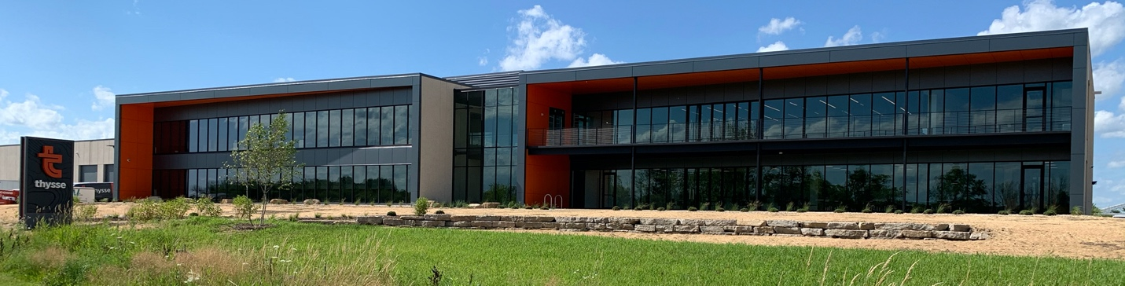

Thysse Has a New Home

Thysse announces its completed move to their new campus. Three times larger than the previous office, this state-of-the-art workspace will be leveraged to provide expanded services for its clients while providing the company with further room for growth.

The move also allows the whole Thysse Team to be under one roof again, an important step for a company that believes people are still its greatest asset. Thysse president, Jason Thysse is proud of the accomplishment and recognizes the work needed to make the project a success,

"Since my grandfather started Thysse in 1941, this company has always been about the people. We designed the new campus with both client and employee needs in mind, and the result we’ve realized with the team of Thysse architects, designers, and assistance from OPN Architects is a dream come true. We are very excited for this next chapter in Thysse’s story!"

Thysse’s new address, as of July 27th, is 780 Cusick Parkway, Oregon, WI 53575.

About Thysse
Thysse is an ever-evolving company built by three generations of visual communication specialists. We like to say Thysse is “Where you go with your brand,” and provide innovative solutions to back that statement up. We are a design, printing, specialty graphics, and manufacturing company at our core, but we also offer imagination and the tools to customize your project to find the right solution every time.

We believe the story your brand tells is as important as the materials its printed on, and we’re here to help you think through every step of your project, be it direct mail, catalog, fleet vehicles, apparel, signage, or environmental wayfinding.

Give us a call and see where your brand can go with us.

To stay up to date with what’s happening at Thysse, visit www.thysse.com.

For more information, contact Jen Braga, Thysse, at 608.249.6951.

