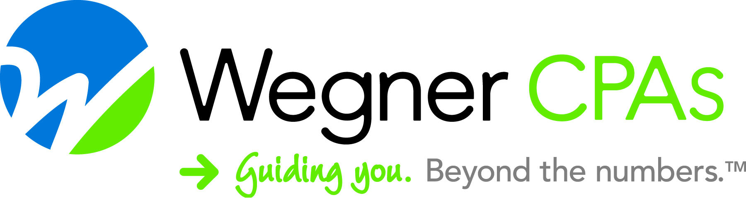

**FOR RELEASE FMI: Fallon Morrissey, 608.442.1922**

**October 1st, 2021 fallon.morrissey@wegnercpas.com**

**Leadership Team Expands at Wegner CPAs**

**October 1st, 2021 - Madison, WI –** With the continued momentum of growth and expansion at Wegner CPAs, the training, development, and promotion of new leaders is imperative to the success of the firm. Tim Seidel, CPA, has recently been appointed to the position of Partner in the Assurance Department. Tim has been a driving force in the Assurance Department for over ten years with his diverse client experience, in addition to his keen management skills. Seidel works with a wide range of clients including nonprofit organizations, manufacturers, construction contractors, grain elevators, and family businesses. He is passionate about working with his clients to provide the insight and knowledge necessary to reach their long-term goals.

“I’m excited and honored to become a partner at Wegner CPAs,” said Seidel. “I love developing relationships with our clients and helping with their accounting, financial, and tax needs. I’m looking forward to continuing the growth and success of our clients, staff, and firm.”

“Tim Seidel has been a key part of Wegner CPAs continued success, and we know he will play an essential role in shaping the future of our Firm,” said Glenn Miller, CPA, CGMA, Managing Partner at Wegner CPAs. “Wegner CPAs and our clients will certainly benefit from Tim’s expertise in the years to come.”

**About Wegner CPAs**

Headquartered in Madison, WI, Wegner CPAs brings a unique perspective to the practice of accounting and business consulting. The firm specializes in closely held businesses, contractors, cooperatives, manufacturers, nonprofit organizations, and municipalities with a complete range of accounting, audit, tax, and consulting services across the lifecycle of the organization. For more information, visit [www.wegnercpas.com](http://www.wegnercpas.com) or call 888-204-7665.

*###*